CardioCell developing stem cell therapy for chronic heart failure By MEGHANA KESHAVAN May 29, 2015 at 6:00 AM

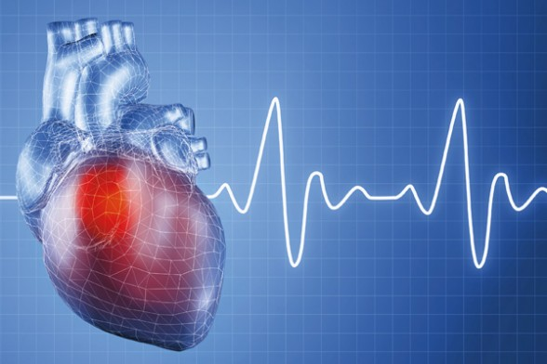
San Diego biotech CardioCell seems to be progressing nicely in developing a stem cell-based therapy for chronic heart failure.
The startup is in Phase 2a clinical trials at four U.S. sites for chronic heart failure: Northwestern University, University of Pennsylvania Medical Center, Emory University and Stony Brook University.
It just raised a $1 million equity round, according to a regulatory filing. Its therapies are directed toward chronic heart failure, acute myocardial infarction and peripheral artery disease. Here’s how CEO Sergey Sikora posits the chronic heart failure therapy works:
Chronic heart failure occurs when the ejection fraction – that is, the amount of blood pumped out of the left ventricle – starts decreasing. The heart starts working in overdrive to maintain this ejection fraction, but the heart muscles just aren’t working accurately.
However, as Sikora explains, the heart muscles – or myocardium – remain totally viable.
“If pathologists take the heart of a diseased person that died of heart failure, they can barely find anything wrong with it because all the cardiomyocytes are OK,” Sikora said.
These heart cells are perfectly viable but for some reason have gone dormant – which is what CardioCell’s stem cell therapy is aiming to address.
CardioCell injects allogeneic stem cells intravenously. The gravitate toward the reservoir organs, Sikora said, such as the spleen and liver, and reside there until the heart releases signals – cytokines – to release these stem cells.
In preclinical trials, CardioCell has found that its stem cells don’t turn into cardiomyocytes but instead release cytokines and various growth factors that potentially assist in regeneration of the heart.
“We think the stem cells are reacting to the cardiomyocytes – they work as a homing mechanism – so then the stem cells go to the site of the injury,” Sikora said.
The stem cells potentially release different growth factors, or cytokines, which help the viable (but not functional) heart cells start working again.
All heart failure patients in the Phase 2a trial are receiving the stem cell therapy – for the first three months, half the group will get the stem cells and the second won’t. For the next three months, this will switch.

